TEAM BUILDER/ICE BREAKER IDEAS (VIRTUAL)

TEAM BUILDER #1
Online and In-House Scavenger Hunts by Teams
Quick Version: Use one of the two graphics below to share on your screen at the beginning of meeting. Give YACers 5 minutes to grab some of these items as fast as they can. When they come back go through the list and have people hold up their items they’ve found. The person who holds up the most items wins. If people don’t have camera capabilities have them put a “.” in the chat every time they have an item when its announced.

Teambuilding Version: Come up with a list of items individuals need to find in their house or online (See Attachment One provided below). Also come up with a list of questions/riddles individuals needs to crack together/search online for. Now post these questions in a few separate google docs.

Split your group into teams and send them to their individual breakout rooms. After doing so, share one of the question google docs so each team has their own separate file. Have teams collaborate for 15-20 minutes on finding the objects in their homes/online and looking for the answers to the questions online. For the items have each group post a photo of the object they found in the google doc.
Bring everyone back together to check answers and see who won!
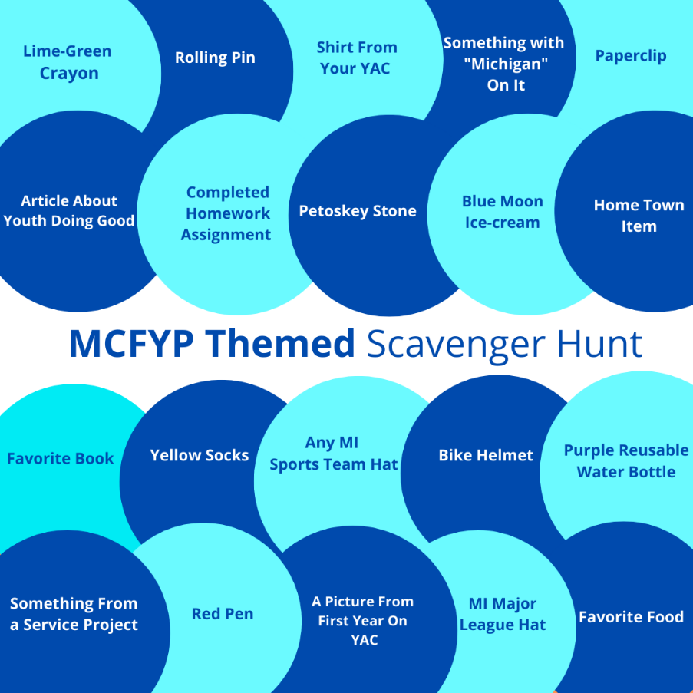
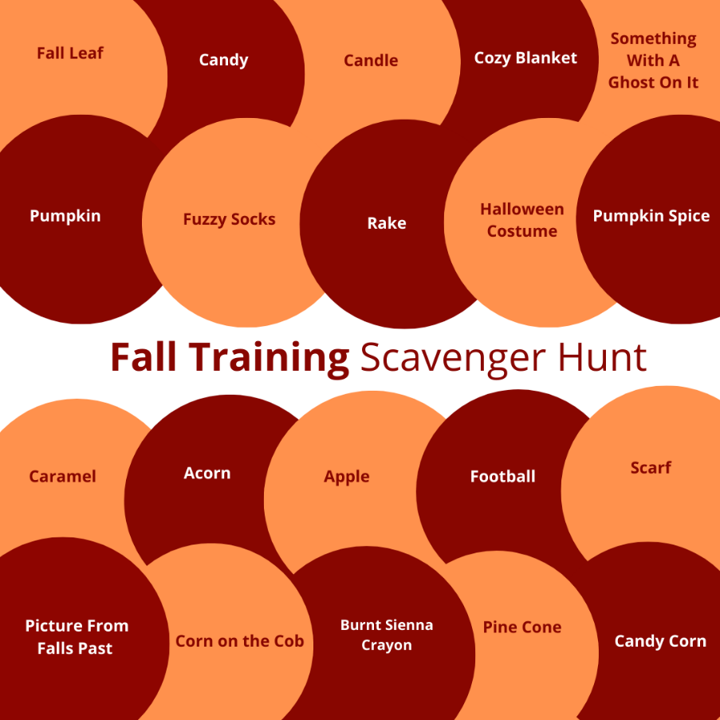
Items to find in house:
- Lime green Crayon
- Rolling Pin
- A shirt from your YAC
- Something that has the word Michigan on it
- Paperclip
- Something from a past Summer Youth Leadership Conference
- Newspaper article about youth doing good (has to be in print)
- Petoskey Stone
- Blue Moon Icecream
- A homework assignment
- Purple reusable water bottle
- Anything with the name of your hometown on it
- Something that has a one of these Michigan cities’ names on it: Detroit, Lansing, Traverse City, Marquette, Grand Rapids, Luddington
- Bike helmet
- Yellow socks
- Any Michigan Major League Sports Team Hat
- A favorite book
- Something from a service project you were apart of
- A red notebook
- Favorite Food

TEAM BUILDER #2
Trivia Game
Everyone loves trivia! Test the general knowledge or program knowledge of your team members by asking multiple choice or True/False questions at the start of the meeting. You can start with a question regarding your program, for example who has worked within the community foundation for the shortest period of time? Or some current affairs questions, to see who’s been paying attention to the news.
How does it work?
- Create a new blank board/document and write the questions in a text box or chart (See Attachment Two provided below).
- If you’re using multiple choice questions, provide four possible answers and ask participants to place colored dots or initials next to the correct answer. For True/False questions, just add True or False as text boxes/options to the board/document.
- If you’re leaving it open, ask participants to write their answers in a text box around the board.
If you want to create trivia teams, you can separate your team into smaller color-coded groups and create a point system. You can create individual boards for each group so they can communicate via chat or in breakout rooms to come up with the best answers. All groups can then meet back together in one board to share their answers. Having a point system will create a friendly competition to keep everyone engaged and continue the flow of conversation!

Online Questions/Riddles:
- Find a picture of your YAC from 10 years ago
- Find an article about your community foundation not produced by your community foundation but another source
- Find the year one of your most recent grantee organizations was founded
- Find the first post your YAC/Community Foundation ever put out on their social media accounts
- Write down the names of the two 2020 YAC of the Year Award Winners
- What was the name of Russell G. Mawby’s speech that discussed why he chose to start a challenge grant for YACs in the early 1990’s?
- What year was your area’s community foundation founded?
- According to the YAC Best Practices Manual, what is the minimum number of YAC members you should have?
- What year was first year youth could start serving on adult boards
- How many virtual breakout sessions were released by the MCFYP committee this summer?
- Finish the quote “Life’s most persistent and urgent question is “____________”
- Who said “I will not beg world leaders to care for our future. I will instead let them know change is coming whether they like it or not”
- Answer this riddle: All 5 sisters are busy. Ann is reading a book, Rose is cooking, Katy is playing chess, and Mary is doing the laundry. What is the 5th sister doing?
- Answer this riddle: Three doctors said that Robert is their brother. Robert says he has no brothers. Who’s lying?
- Answer this riddle: Two in a corner, 1 in a room, 0 in a house, but 1 in a shelter. What am I?

Answers:

5. Write down the names of the two 2020 YAC of the Year Award Winners
  - MPACF YAC for Media Usage of the Year and Lindsey Clarke for Passion in Philanthropy
6. What was the name of Russell G. Mawby’s speech that discussed why he chose to start a challenge grant for YACs in the early 1990’s?
  - “Why Youth”
7. What year was your area’s community foundation founded?
  - Depends on group
8. According to the YAC Best Practices Manual, what is the minimum number of YAC members you should have?
  - 12
9. What year was first year youth could start serving on adult boards
  - (1998)
10. How many virtual breakout sessions were released by the MCFYP committee this summer?
  - 8
11. Finish the quote “Life’s most persistent and urgent question is “____________”
  - “What are you doing for others” Martin Luther King Jr.
12. Who said “I will not beg world leaders to care for our future. I will instead let them know change is coming whether they like it or not”
  - Greta Thunberg
13. Answer this riddle: All 5 sisters are busy. Ann is reading a book, Rose is cooking, Katy is playing chess, and Mary is doing the laundry. What is the 5th sister doing?
  - Playing Chess
14. Answer this riddle: Three doctors said that Robert is their brother. Robert says he has no brothers. Who’s lying?
  - No one is lying – Robert has 3 sisters who all happen to be doctors.
15.Answer this riddle: Two in a corner, 1 in a room, 0 in a house, but 1 in a shelter. What am I?
  - The letter “R”

Questions | Answers
- Who has most recently won the best new artist Grammy? | - Billie Eilish  - Lizzo  - Little Nas X  - Rosalia
- How many Marvel Superhero Movies have there been since 2008? | - 18  - 10  - 23  - 29
- True or Flase the average carbon footprint of an American is 16 tons | - True  - False
- What is the third color in the MCFYP logo? (you just saw it on the first slide!) | - Magenta  - Purple  - Sky blue  - Yellow
- How many counties are there in the state of Michigan? | - 25  - 92  - 45  - 83
- True or False: the state fruit is the Granny Smith Apple? | - True  - False
- How many state representatives are there in Michigan? | - 15  - 110  - 86  - 125
- How old was the youngest person to address the Human Rights Council at the UN? | - 8  - 5  - 17  - 12
- What year were Youth Advisory Councils Created? | - 1991  - 1997  - 1986  - 2001
- What musical term is indicates a chord where the notes are played one after another rather than all together? | - Break  - Arpeggio  - Adagio  - Cadence
- What is the third sign of the Zodiac? | - Gemini  - Capricorn  - Sagittarius  - Pices
- What is the height of a basketball hoop in feet? | - 8 feet  - 10 feet  - 9 feet  - 12 feet
- How old is the MCFYP program? | - 30 years  - 15 years  - 28 years  - 22 years
- True or False: Community foundations 501c3 nonprofit organizations | - True  - False
- Who was the Kellog’s Foundation Executive Director that started the MCFYP program? | - Robert S. Collier  - La June Montgomery Tabron  - Sterling K. Speirn  - Russell G. Mawby

Answers:
- Billie Eilish
- 23
- True, 12 tons over the average global citizen
- Purple
- 83
- False, it’s the cherry!
- 110
- 12, Dujuan Hoosan addressed the UN about the wrongful incarceration of young children in Australia
- 1991
- Appregio
- Gemini
- 10 feet
- 28 years old
- True
- Russell G. Mawby

ICEBREAKER #1
40 second Blah Blah Blah
Prompt your group with a question. This question can help set the tone for your training so please decide/choose wisely. Examples could be:
- Tell us your thoughts and feelings on this coming school year?
- Where do you think our YAC/youth philanthropy group can grow in the future?
- What current events and social issues have had you attention most of this year? How are you feeling about them?
- What are some of your goals for this year?
Tell participants they will have 40 seconds each to just blurt out their feelings, thoughts, initial reactions, etc. To the prompts. Remember to put boundaries in place (keep it clean, not offensive, etc.)

ICEBREAKER #2
Virtual This or That

Give participants this or that scenarios.
Example:
- Chocolate or Vanilla
- Pop Music or Hip-Hop Music
- Disney or Nickelodeon
Have the participants add their preferred choice (or even say they’re in the middle) to their name box. Then have people debate/defend their choices.

ICEBREAKER #3

Two Lies and a Truth

Ask each team member to prepare a list of three interesting "facts" about themselves, two of which must be made up. These could be anything, from a pet they own or a hobby they love to a famous person they've met.
Then, get other team members to pick which of the statements is true. The team member who receives the most incorrect votes "wins."

